Difference Between TDD and BDD Methodologies

1. Introduction
TDD (Test-Driven Development) and BDD (Behavior-Driven Development) are software development methodologies that improve code quality and project clarity. Both involve writing tests early but differ in focus and collaboration.

2. What is TDD?
TDD is a developer-focused approach where tests are written before the actual code. It ensures each unit of code performs correctly.

TDD Cycle (Red → Green → Refactor):
• Red: Write a failing unit test.
• Green: Write minimum code to pass the test.
• Refactor: Optimize the code while tests remain green.

Benefits of TDD:
• Ensures clean, modular code.
• Reduces bugs early.
• Improves developer confidence.
• Suitable for backend logic and APIs.

3. What is BDD?
BDD extends TDD by focusing on user behavior and business expectations. It uses natural language scenarios that even non-technical stakeholders can understand.

BDD Format (Gherkin):
Given initial context,
When an action occurs,
Then an expected outcome happens.

Benefits of BDD:
• Strong collaboration among Dev, QA, and Business.
• Requirements are clearer and validated.
• Acts as living documentation.
• Best for user-facing features.

4. Key Differences Between TDD & BDD
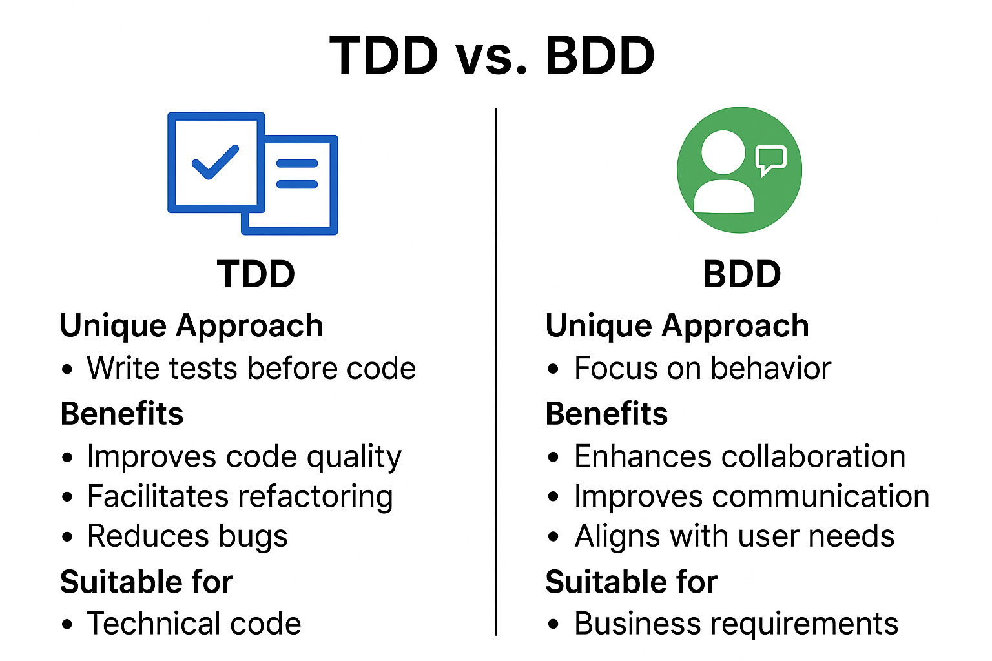

• Focus: TDD checks code correctness; BDD checks user behavior.
• Participants: TDD involves developers; BDD includes developers, testers, and product owners.
• Test Style: TDD uses technical unit tests; BDD uses readable scenarios.
• Usage: TDD suits logic-heavy systems; BDD suits feature-rich applications.

5. Suitability
Use TDD when:
• You need strong unit-level accuracy.
• The system has complex internal logic.
• Working mainly on backend or algorithms.

Use BDD when:
• Requirements need clarity.
• The system is user-facing.
• Collaboration between teams is essential.

6. Conclusion
TDD ensures correctness of code units, while BDD ensures that software behaves as users expect. Both improve software quality, but the choice depends on whether the project prioritizes technical accuracy (TDD) or business clarity and user behavior (BDD).

